An Essential Sporting Weekend:
Liverpool
Contents:
- Our Pub, Hotel, Activity & Restaurant partners
- A perfect Liverpool weekend itinerary
- Where to watch your Sport & pubs around Goodison

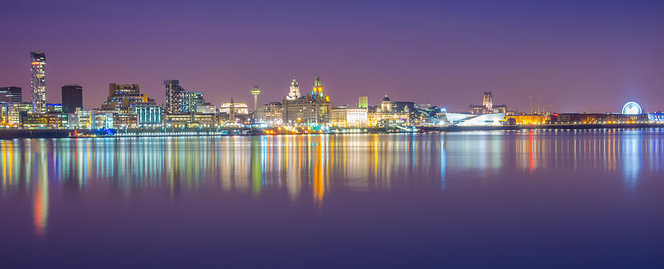

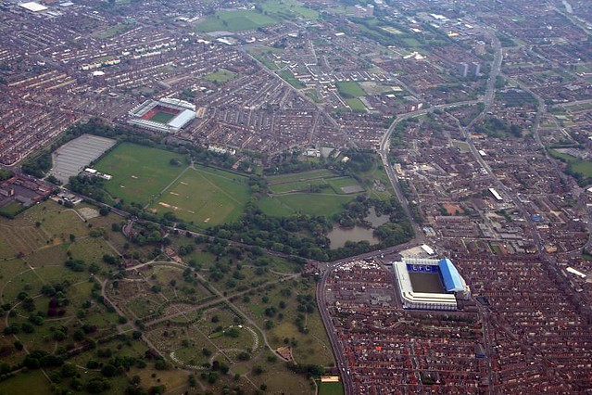

Our Pub Partners:
The Excelsior – Great traditional pub at the top end of Dale Street, easy walking distance from Lime Street station. Ever changing real ales, Sky Sports, food & Dart board.
The Excelsior (excelsiorliverpool.co.uk)
Denbigh Castle – Situated on Hackins Hey just tucked around the back of Dale Street, this is a fairly new gem of a drinking pub. With a great selection of German beers, spirit & wine options to suit everyone.
The Denbigh Castle Liverpool
Baltic Fleet – One of the most historic city centre Liverpool pubs that often gets forgotten about. Shaped like the front of a boat this pub sits on The Strand opposite the M&S Arena & Albert Dock. A great traditional pub, now a grade II listed building, to visit after seeing the tourist sites around the docks.
Home (balticfleet.co.uk)
Ma Egerton’s Stage Door – Right outside the back entrance of Lime Street station is our favourite ‘last one before the train home’ bar. With great pictorial memories on the walls of theatre stars past & present, this pub offers friendly staff, great pizza & a real Liverpool atmosphere on matchdays.
Ma Egerton's - Liverpool's Most Famous Landlady (maegertons.com)

The Angus – A new edition to the bar scene at the bottom end of Dale Street opposite the old town hall. Live music is on most of the busier nights and has an independent feel with a great atmosphere.
The Angus Tap & Grind Liverpool | Home

Our Restaurant Partners:
Il Forno – Classic, inspiring Italian cuisine based on Duke Street. A friendly and quality driven team produce a menu everyone can enjoy, with a passionate team to serve you.
Il Forno - The fine art of Italian dining

Fazenda – If you like meat then this is a must visit! The all-you-can-eat restaurant offers many Brazilian grilled meats to your table. The salad buffet is just worth the visit alone, not only fresh salad, but amazing cured meats and cheese await. Located in Exchange Flags around the back of the old town hall.
Fazenda Liverpool - Exchange Flags

The Brunch Club – For your hangover breakfast head over to The Brunch Club, brilliant food and a home cooked feel. Be warned gets very busy on weekend days between 10am-1pm.
The Brunch Club Liverpool
Duke Street Food Market – Great for you if you’re in a group with different food tastes! Loads of different cuisines to choose from and a decent bar means a good choice if wanting a more refined atmosphere.
Duke Street Food & Drink Market (dukestreetmarket.com)
Baltic Market – Similar to Duke Street but on a much bigger scale. Located on the old Cains Brewery site, make sure you visit this regenerated part of town.
Baltic Market
Our Hotel Recommendations:
Stylish & Great Location:
Titanic Hotel – Hotels in Liverpool | Luxury Hotels Liverpool | Titanic… (titanichotelliverpool.com)
Pullman Hotel – Pullman Liverpool | WEBSITE ✅ | Liverpool | Merseyside | England (com-liverpool.info)
Hope Street Hotel – 4 Star Hotel Liverpool | Luxury Boutique Hotel UK (hopestreethotel.co.uk)
Heywood House Hotel – Boutique Hotel in Liverpool City Centre | Best Rates Guarantee (heywoodhousehotel.co.uk)

Budget & Great Location:
Ibis Styles (Dale Street) – Ibis Styles Liverpool Dale St | Stylish Hotel in Liverpool - ALL (accor.com)
Hotel Indigo – Hotel Indigo Liverpool, an IHG Hotel | Liverpool - Merseyside | England (com-liverpool.info)
Holiday Inn Express (Albert Dock) – Holiday Inn Express Hotel Liverpool - Albert Dock (ihg.com)
Aloft Hotel – Boutique Hotel in Liverpool | Aloft Liverpool (marriott.com)
Chavasse Apartments – Serviced Accommodation in Liverpool - The Chavasse Apartments

Something a bit different:
Dixie Dean Hotel – The Dixie Dean Hotel
The Resident – The Resident | Boutique Hotel | Liverpool (residenthotels.com)
Pembroke Studios – Pembroke Studios, Liverpool | Homepage
Castle Collection (Castle Street) – Home: The Castle Collection

48 Hours in Liverpool:
Aside from probably watching Everton at Goodison Park, what else can you do with your time in the city?

Ferry Across The Mersey:
Now you’re singing aren’t you?! One of the classic things to do, and gives you a great view of the city skyline that you can only get on the water or over in Birkenhead.
Mersey Ferries | Liverpool Ferry

Liverpool Museums & Galleries:
Did you know this city has the most of these in the UK aside from London? The introduction of the City Museum has also increased the more family friendly element to them. The Walker Art Gallery always has a major exhibition on.
National Museums Liverpool (liverpoolmuseums.org.uk)

Beatles Museum & Tour:
The ‘must do’ of the weekend surely?! The Beatles put the city on the map in the 1960’s, follow their journey at the Beatles Museum on Albert Dock. Also venture out and check where the original Strawberry Field is & where they grew up.
Liverpool Beatles Museum | The largest Beatles collection in the world

Goodison Park Tour:
If you’re here on a non matchday it doesn’t mean you can’t visit Goodison Park. Steeped with footballing history, 1st three tiered stand, the only club ground to host a World Cup semi-final & the history of the Toffees.
Stadium Tours | Everton Football Club (evertonfc.com)

Liverpool One Shopping Centre:
The design of the city centre changed dramatically in 2008 with the new L1 shopping centre. Built into the old docks it’s an iconic & fitting centre for the city. Explore the shops, play crazy golf, grab lunch & catch a film.
Liverpool Shopping - Visit Liverpool ONE (liverpool-one.com)

Liverpool Historic Pub Crawl:
Visit some of the most historic pubs in the city, the stories these walls could tell! Rather than just go to any pubs, check these out for an authentic Liverpool pub experience.
Pub crawl of Liverpool’s most historic watering holes - Liverpool Echo

Catch a gig & theatre show:
The now re-named M&S Bank Arena (everyone still calls it the Echo Arena) hosts plenty of concerts or shows all year round. You also have a couple of theatres in town for any shows. Check out the links below for what you can see…
M&S Bank Arena Liverpool | M&S Bank Arena Liverpool (mandsbankarena.com)
What's On in Liverpool & Surrounding Area (liverpooltheatres.com)

Crosby, Southport & beyond:
If you find yourself in the area in the Spring & Summer months then these areas are well worth a visit. Crosby beach has the famous ‘Another Place’ statues & Southport offers you a theme park, beach & good nightlife without the mainstream affair that is Blackpool up the coast. Check if Aintree races are on too, that’s a great day out especially in April for the Grand National meeting!
Crosby Beach - Visit Southport
Aintree Racecourse | 2021 | Aintree, Liverpool (thejockeyclub.co.uk)

Pubs Around Goodison Park:

Winslow Hotel:
The legendary pub right on Goodison Road had a refurb a few years ago & is back to it’s best. Get in early on matchdays as it gets very busy. They also show the matches live & have ex-player events from time to time.
Welcome to The Winslow Hotel at the Goodison Park in Liverpool

Hot Wok:
On the corner of the Park End/Goodison Road axis is the Hot Wok which has recently turned into a pre & post match venue with ex-players speak afterwards, food & drink packages available. Booking is recommended.
Hot Wok | Hot Wok | Takeaway Restaurant | Liverpool | L4 (hotwokliverpool.co.uk)

The Brick:
Just down from Goodison Road on County Road is The Brick pub, which has always been a full on Everton pub. They run away travel groups to away games too. Follow them on Twitter below:
The Brick Pub (@Thebrickpub) / Twitter

